**Project Documentation**

CookBook : Your Virtual Kitchen Assistant

# 1. Introduction

**Project Title:** CookBook : Your Virtual Kitchen Assistant

* **Team ID** : NM2025TMID42323
* **Team Leader:** M.Kaviya/kaviya2007001@gmail.com
* **Team Members:**

•S.Kaviya/ kaviyasmani2007@gmail.com

•M.Keerthana [/mkeethana6583@gmail.com](mailto:/mkeethana6583@gmail.com)

•N. Keerthana /keethananalamuthu

# 2. Project Overview

**•Purpose: CookBook is a web application designed to revolutionize the wayusers discover, organize, and create recipes. It caters to both novice andprofessional chefs, offering a user-friendly interface, robust features, and a vastcollection of international recipes**

* **Features:**

•Access to a vast library of international recipes via the MealsDB API.

•Visual recipe browsing with curated image galleries

•Intuitive and user-friendly design with a clean, modern interface.

•Advanced search functionality for easy recipe discovery.

•Comprehensive recipe management, including saving and sharingrecipes

# 3. Architecture

**•Component Structure: The application is divided into components, pages, andstyles.**

**• Components: Reusable UI elements like Navbar, Hero, Footer, andNewsletter.**

**•Pages: Home, Category, and Recipe pages that represent different URLroutes.**

**•Styles: CSS files for styling each component and page**

**State Management:**

**•The application uses React’s useState and useEffect hooks for managinglocal state within components.**

**•No global state management library (e.g., Redux) is used, as theapplication’s state is primarily local to each component**

# 4. Setup Instructions

* **Prerequisites:**

Setup Instructions:

Prerequisites:

•Node.js&npm installed→[Download Node.js](<https://nodejs.org/en/download/)React.js>

•Knowledge – Basic understanding of React components and hooks.

•CodeEditor Recommended:

[VSCode](https://code.visualstudio.com/download

* **Installation Steps:**

Configure the database, build the solution in a development environment like visual studio, and then run the application.

# 5. Folder Structure

The structure simple but scalable to accommodate project growth.

# 6. Running the Application

* **Frontend:**

Cookbook to the project’s frontend, and then use a specific command provided by the project framwork launch.

* **Backend:**

Creating the server- side logic, database, and APIs that cookbook application.

* **Access:**

Visit http://localhost:3000

# 7. API Documentation

* **User:**

This often includes examples for authentication, creating data, retriving data, and managing user information.

•**Chats:**

•JWT- based authention for secure login

•The client includes this JWT in the authorization header subsequent requests to the backend.

# 8. Authentication

•Middleware projects private routines

Redirect the user to a login page or send an “Access Denied” response, ensuring that only authorized users can access sensitive parts of the application.

# 9. User Interface

•Landing Page

This page introduces the project, highlighting key features and a clear value proposition

To attract users and encourage them to sign up or explore further.

• Freelancer Dashboard

Auser interface for freelanc

# 10. Screenshots or Demo

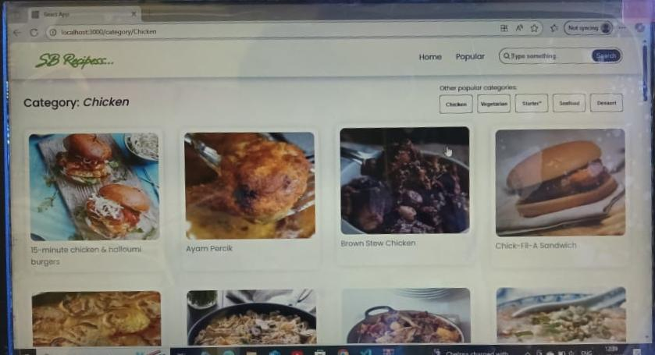

1. **Known Issues :**

Data resets on page refresh (no persistent storage)..No authentication system implemented..

# 12.Future Enhancements :

Correct backend with Node.js + Express + MongoDB.

Implement user login & authentication..

Add checkout and payment system.

Create sales tracking & report